**ASSIGNMENT 1 FRONT SHEET**

|  |  |  |  |
| --- | --- | --- | --- |
| **Qualification** | **TEC Level 5 HND Diploma in Computing** | | |
| **Unit number and title** | **Unit 43: Internet of Things** | | |
| **Submission date** | 5/4/2020 | **Date Received 1st submission** |  |
| **Re-submission Date** |  | **Date Received 2nd submission** |  |
| **Student Name** |  | **Student ID** | DuyNTGCD17313 |
| **Class** |  | **Assessor name** | Trong Minh |
| **Student declaration**  I certify that the assignment submission is entirely my own work and I fully understand the consequences of plagiarism. I understand that making a false declaration is a form of malpractice. | | | |
|  | | **Student’s signature** | Duy |

**Grading grid**

|  |  |  |  |  |  |  |  |  |  |
| --- | --- | --- | --- | --- | --- | --- | --- | --- | --- |
| P1 | P2 | P3 | P4 | M1 | M2 | M3 | M4 | D1 | D2 |
|  |  |  |  |  |  |  |  |  |  |

|  |  |  |
| --- | --- | --- |
|  **Summative Feedback:**  **Resubmission Feedback:** | | |
| **Grade:** | **Assessor Signature:** | **Date:** |
| **Internal Verifier’s Comments:** | | |
| **Signature & Date:** | | |

# Table of content

Contents

Table of content 3

-LO1 Analyse what aspects of IoT are necessary and appropriate when designing software applications 6

=P1 Explore various forms of IoT functionality. 6

Definition about IoT 6

Overview of the Internet of Things 6

Fundamental Characteristics of Internet of Things 10

=Applications of IoT explain them all but not list them out 10

Some examples for real world application of IoT 10

For example: 10

- IOT-POWERED SAFETY MONITORING 12

-SMART ENERGY IOT 13

-IOT FOR SENSOR DATA 14

-MERGING IOT AND RETAIL COOLERS 15

P2 Review standard architecture, frameworks, tools, hardware and APIs available for use in IoT development. 16

Standard architectures 16

Frameworks 18

Tools 19

Hardware 21

APIs 23

-Cloudiot 24

-Cloudiotdevice 25

-LO2 Outline a plan for an appropriate IoT application using common architecture, frameworks, tools, hardware and APIs 26

=P3 Investigate architecture, frameworks, tools, hardware and API techniques available to develop IoT applications. 26

Discuss detail about current architecture, frameworks, tools, hardware and API techniques available to develop IoT applications (you can use the form that you have learned on class for this). 26

-=Architecture 26

1. Edge Analytics 27

2/ Data Centre with Cloud Platform 28

-=Frameworks (https://github.com/SmingHub/Sming, n.d.) 30

=- Hardware Andrunio 32

NodeMCU ESP8266 WiFi Development Board: 32

1. Anduino IoT Product 34

2. Adafruit Range of Development boards 34

-=Tools 34

1. Blynk IoT platform 34

2. The Integrated Development Environment (IDE) 36

-=API techniques 38

AWS IoT 38

P4 Determine a specific problem to solve using IoT. 39

Problem: 39

Discuss about the reason for your selection 39

Solution: 41

Sensor dht11 arduino 41

Sensor Servo SG90 42

Draw DEMO my smart IOT for control the Soil & air moisture for plant watering 44

Table -Connect sensor with Arduino circuit 44

Sensor Servo SG90 44

ESP8266 44

**Arduino UNO R3** 44

# -LO1 Analyse what aspects of IoT are necessary and appropriate when designing software applications

# =P1 Explore various forms of IoT functionality.

# Definition about IoT

(htt1)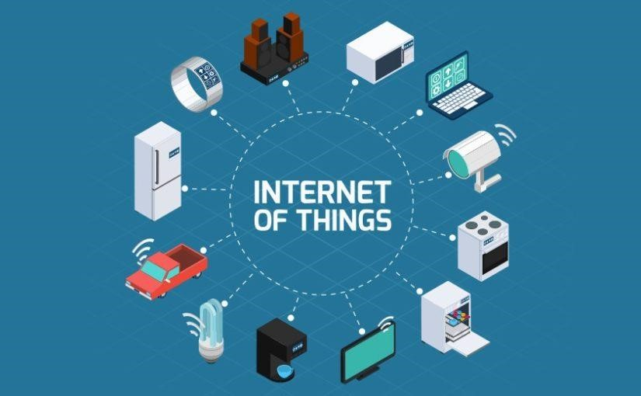

### Overview of the Internet of Things

Internet of Things (IoT) the name is enough to say everything

Over the past few years, IoT has become one of the most important technologies of the 21st century. Now, we can connect everyday appliances Kitchen appliances, cars, thermostats, monitors Kids online over the internet through embedded devices, can seamlessly communicate between people, processes and everything.

IoT technology - Internet of Things is referring to systems techniques that have been developing due to the convergence of many technologies of computer devices that are related to each other (Like billions of physical devices around the world today). connected to the internet, all collecting and sharing data), real-time analysis, machine learning, cargo sensors, embedded systems, digital computers and digital machines, objects , animals or humans are provided with unique identifiers and the ability to transmit data over a network without humans or humans interacting with the computer so that all objects around us can be connected. connection, control, management, monitoring ... through the global internet.

(Biswas, n.d.)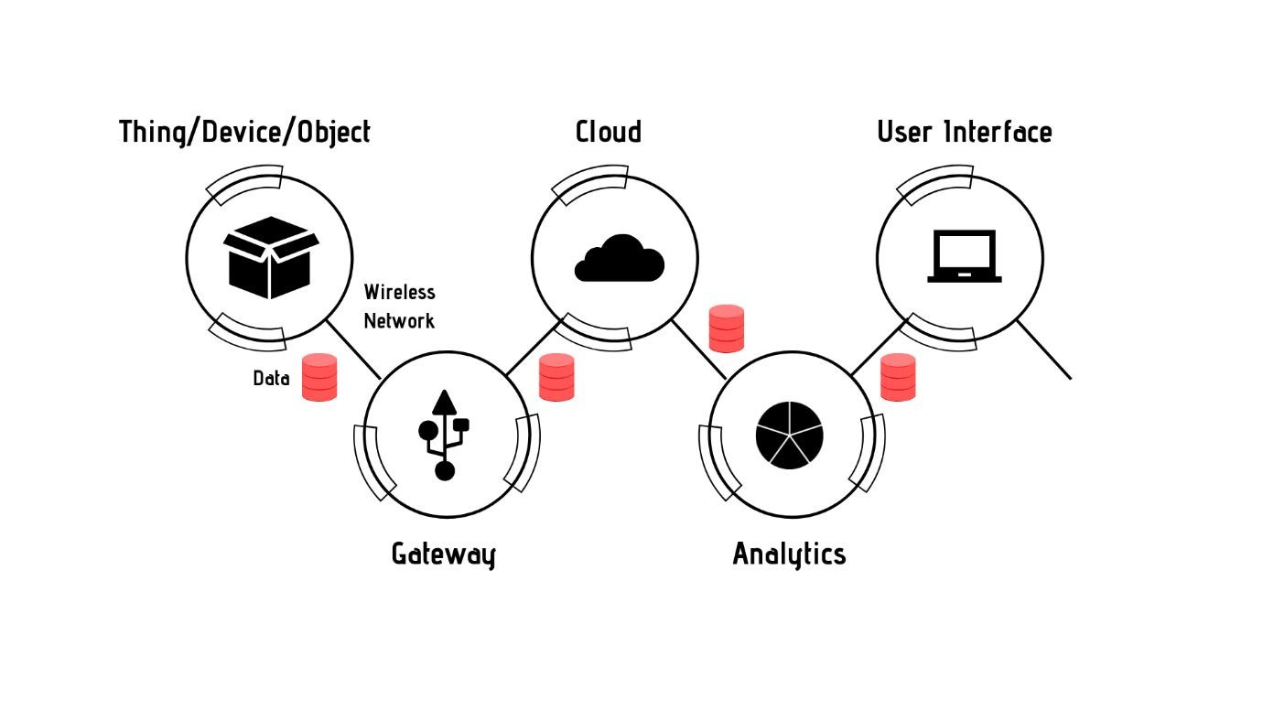

Thanks for the release of super-cheap computer chips and the popularity of wireless networks, you can turn everything from something as small as a tablet into something as big as an airplane, into a part of the IoT.

And with the help of low-cost computing, the cloud, big data, analytics and mobile technology, physical things can share and collect data with minimal human intervention. . In this hyperlinked world, digital systems can record, monitor and adjust each interaction between connected things. The physical world meets the digital world and they collaborate.

Connecting all these different objects and adding sensors to them will add a level of digital intelligence to devices that can be dumb, allowing them to communicate real-time data without regard. to humans. The Internet of Things is making the structure of the world around us smarter and more responsive, integrating digital and physical universes.

The importance of IoT is enormous and has been gaining attention and exploding in recent years, after the development of smartphones, tablets and wireless connections, etc. (IoT has shown its potential with astonishing figures.)

The traditional fields of embedded systems, wireless sensor networks, control systems, automation (including home and building automation) and others contribute to the Internet of everything. . In the consumer market, IoT technology is synonymous with products related to the concept of "smart homes", including devices and equipment (such as lighting equipment, thermostats, security systems family and cameras and other home appliances) support one or more common ecosystems and can be controlled through devices related to that ecosystem, such as smartphones, Smart speakers and smart watches.

Its convenient benefits can completely change the way people live in the future. Once everything has been "Internetized", users can fully control them from anywhere, just a phone with an Internet connection. Having achievements in this field means you are holding the key to success of all time. Internet of Things is the trend of the future.

There are some serious concerns about the dangers of IoT development, especially in the area of privacy and security, and therefore industry and government actions to address concerns. This has started.

## Fundamental Characteristics of Internet of Things

(https://www.educba.com/iot-features/, n.d.)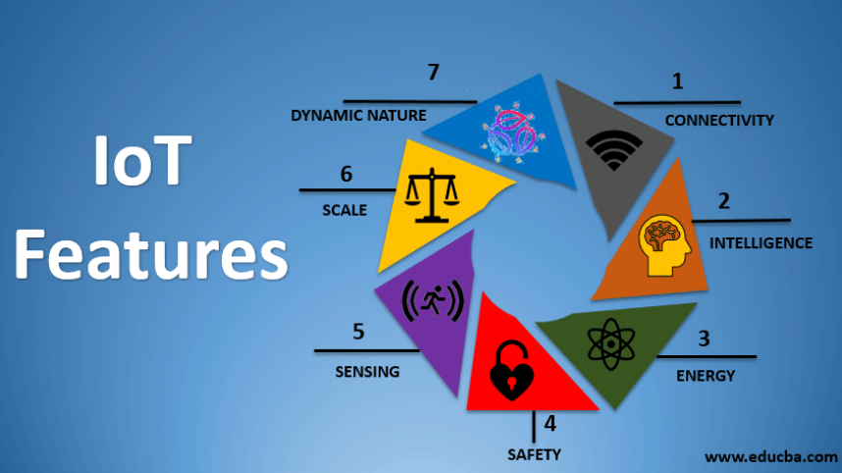

## =Applications of IoT explain them all but not list them out

### Some examples for real world application of IoT

### For example:

Imagine one day you will be away from home on a business trip, school and still be able to manage and monitor your house from a far distance, how convenient would it be?

Or how safe it is to be a smart city of a country if everything, even people, is connected, managed, monitored and notified in a timely manner via the internet.

(Standeford, n.d.)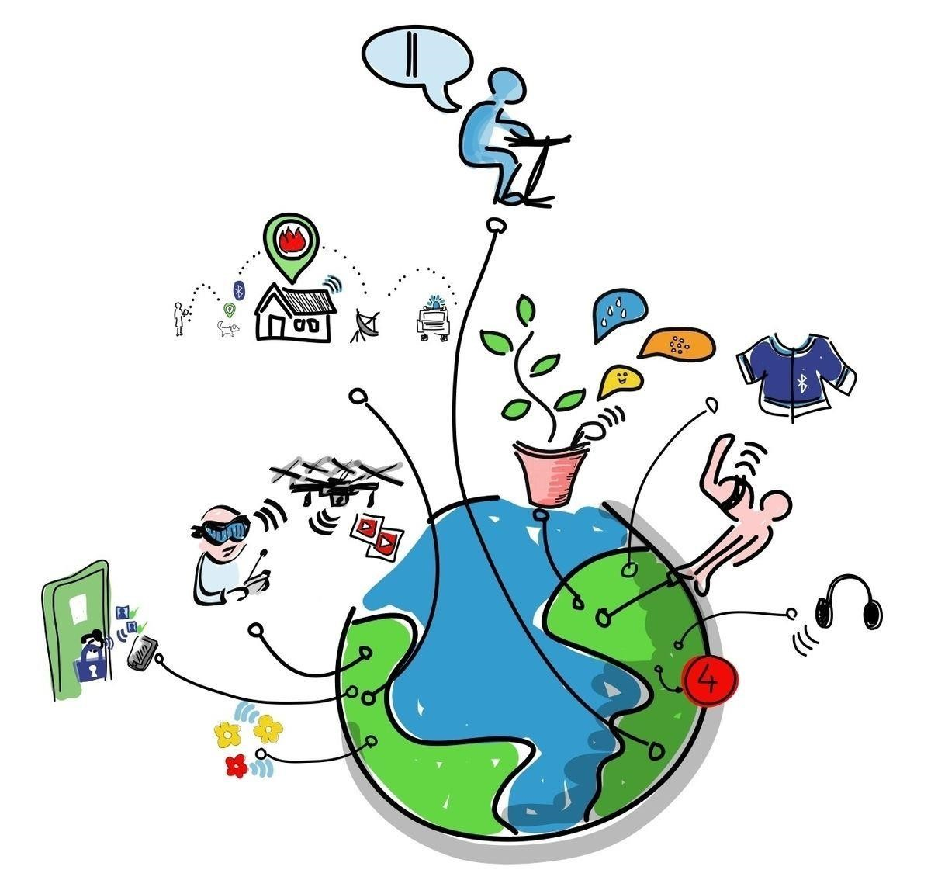

### - IOT-POWERED SAFETY MONITORING

* Industry impact : Telecommunications, Healthcare
* Location: Austin, Texas
* **How they’re using Iot,** what it does:   
  -AlertMedia develops software for mass-alert communication. The firm offers two-way communication and monitoring through its fully integrated cloud-based platform.within the event of an emergency, the SafeSignal app allows users to rapidly inform a monitoring center.  
  (https://builtin.com/internet-things/iot-internet-of-things-companies, n.d.)

### -SMART ENERGY IOT

* Industry impact: Cleantech
* Location: Culver City, California
* **How they’re using Iot,** What it does:   
  -Inspire supplies consumers with greener, more efficient energy. Customers cantakea "smart energy" subscriptionthat features100% renewable electricityfurtheras energy management services.

(https://builtin.com/internet-things/iot-internet-of-things-companies, n.d.)

### -IOT FOR SENSOR DATA

* Industry impact: Transportation, Food, Government
* Location: San Francisco, California
* **How they’re using Iot,** What it does:   
  Samsara's sensor data solutions are designed to boost operational safety and efficiency acrossa large range of sectors. The company's linked sensors make it easier for organizations to regulate, track, and monitor vehicle and fleet operations.  
  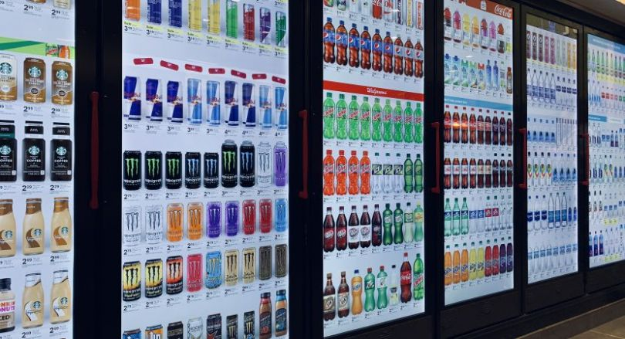

### -MERGING IOT AND RETAIL COOLERS

* Industry impact: Adtech
* Location: Chicago, Illinois
* **How they’re using Iot,** What it does:  
  -Cooler Displays turns the traditionally functional, normally unattractive façade of retail coolers into eye-catching IoT-enabled screens that allow companies to provide real-time discounts and harness customer data while also giving merchants with out-of-stock notifications, warning pricing changes, and more



# P2 Review standard architecture, frameworks, tools, hardware and APIs available for use in IoT development.

- Introduce almost standard architectures, frameworks, tools, hardware and APIs that are available for using in IoT development.

## Standard architectures

* + - 1. Gateways and Data Acquistion
  1. The client side (IoT Device Layer)Frameworks

Smart Apps (Remote Control) with video+ analytic data information display

* 1. Operators on the server side (IoT Getaway Layer)
     + 1. A pathway for connecting clients and operators (IoT Platform Layer)
  2. Analytics Layer (Data Center/cloud) convert the data from gyroscope
  3. Connectivity Layer (Internet Gateways, Data Acquisition System) radio for comunication from each components
  4. Sensor Layer and actuators with controllers (Wifi/ Humidity &Temperature sensor) a camera for watching the visual data
     + 1. Edge Analytics
       2. Data Centre with Cloud Platform

(htt5)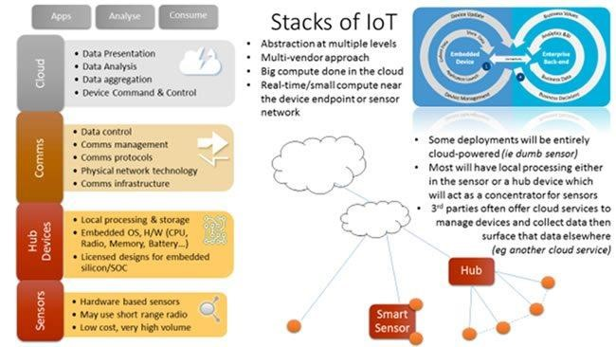

## Frameworks

1. KAA IoT
2. Cisco IoT Cloud Connect
3. Oracle IoT
4. Microsoft Azure IoT
5. Google Cloud Platform – IoT framework
6. IBM Watson – IoT framework
7. Hewlett Packard Enterprise – IoT framework 8. Mindsphere by Siemens – IoT framework

(htt8)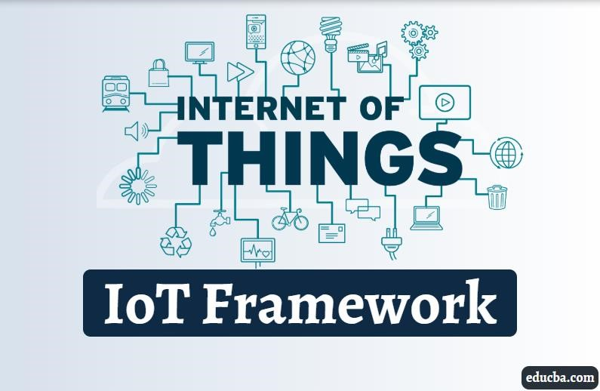

## Tools

There’re some tools that can available for using in IOT development

1. Blynk IoT platform

Develop by current three team members, including Founder and CEO Bayborodin Pavlo



1. Anduino

The Arduino project was started at the Interaction Design Institute Ivrea (IDII) in Ivrea

The project goal was to create simple, low cost tools for creating digital projects by non-engineers

By CEO, Federico Musto and the initial Arduino core team consisted of Massimo Banzi, David Cuartielles, Tom Igoe, Gianluca

Martino, and David Mellis



1. Eclipse IoT
2. AWS IoT
3. ARTIK Cloud
4. OpenBalena Cloud
5. Google Cloud
6. Cisco IoT Cloud Connect
7. AWS Greengrass Cloud

## Hardware

1. Anduino IoT Product

(htt2)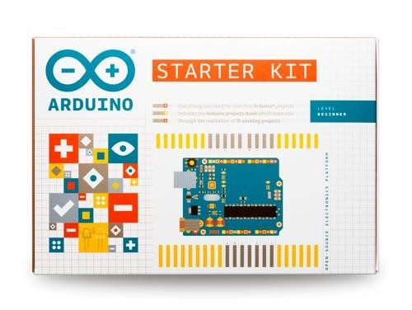

1.1 Arduino board

(htt3)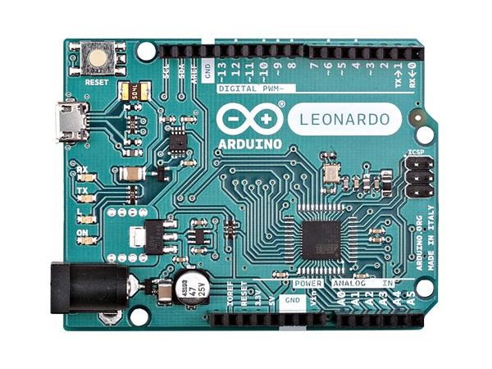

1. Adafruit Range of Development boards

(htt4)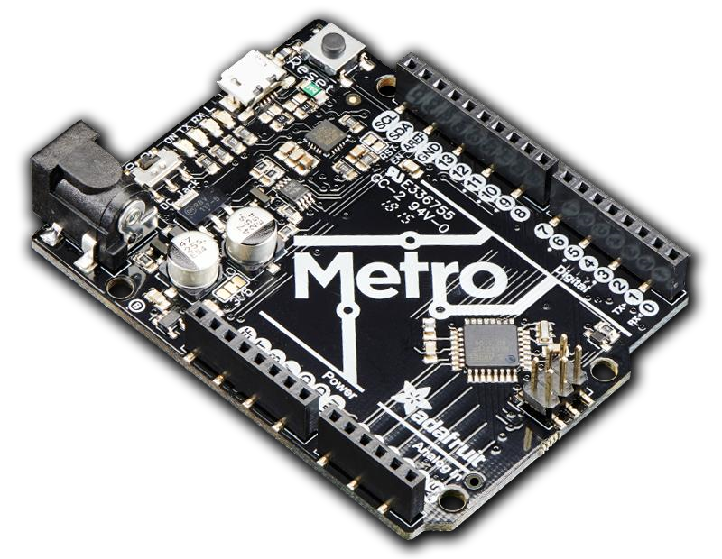

## APIs

What is APIs for IOT

### -Cloudiot

(htt6)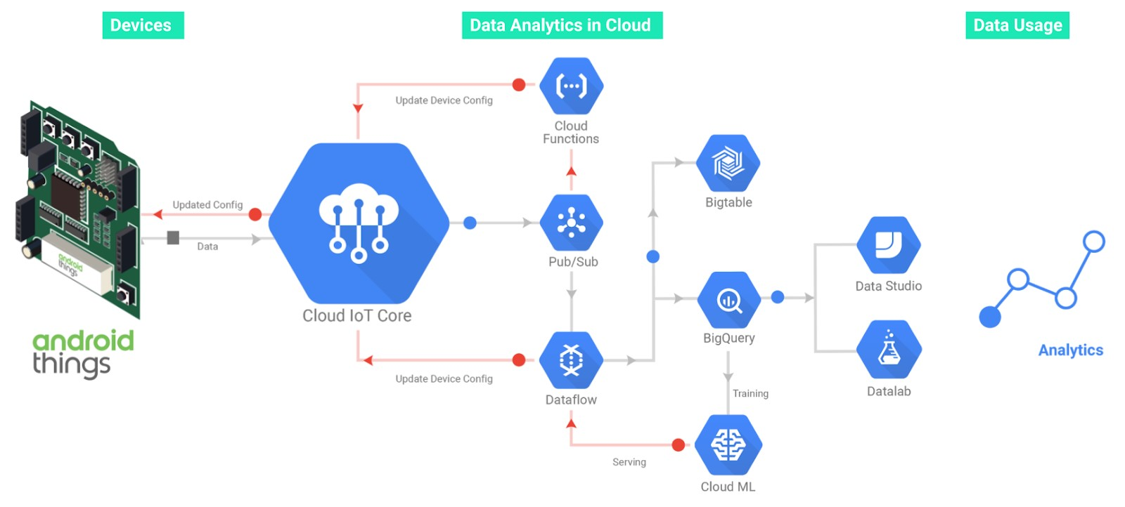

### -Cloudiotdevice

(htt7)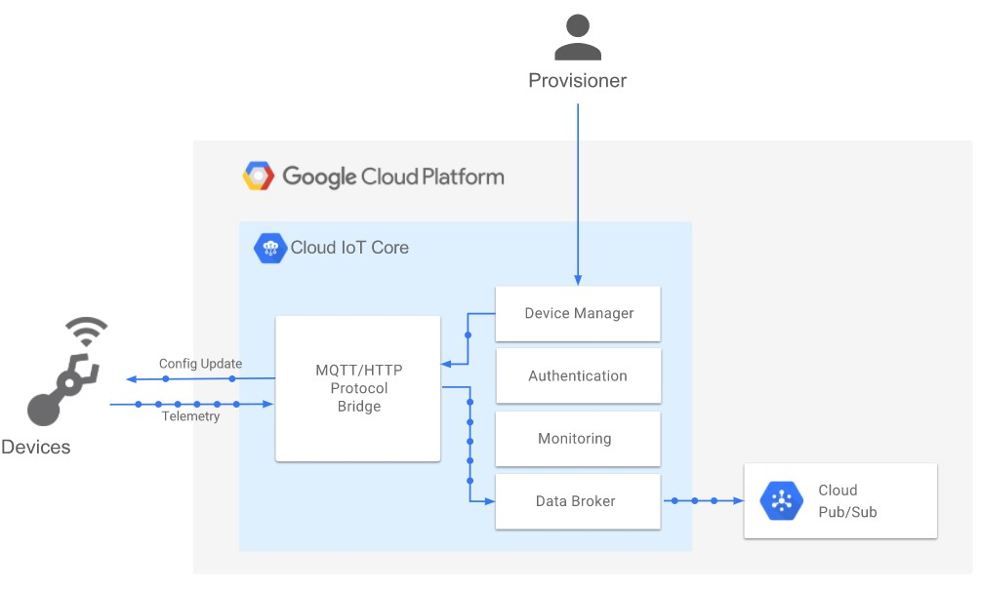

# -LO2 Outline a plan for an appropriate IoT application using common architecture, frameworks, tools, hardware and APIs

# =P3 Investigate architecture, frameworks, tools, hardware and API techniques available to develop IoT applications.

# Discuss detail about current architecture, frameworks, tools, hardware and API techniques available to develop IoT applications (you can use the form that you have learned on class for this).

## -=Architecture

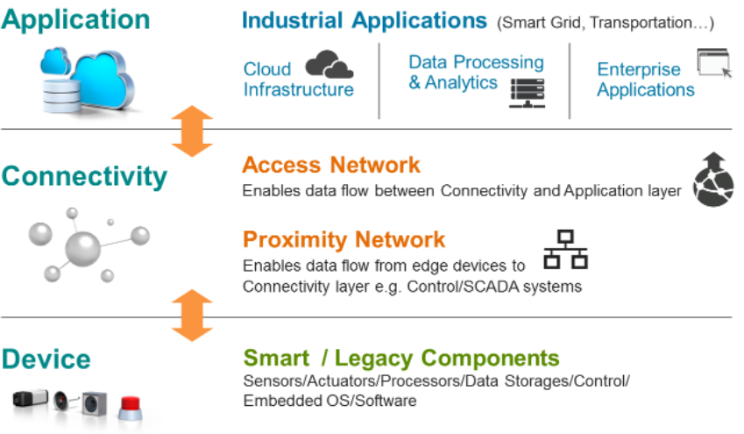

a, The awareness layer is the physical layer, which contains sensors for sensing and collecting ambient data. It detects specific geographical factors or recognizes other smart things within the area.

b, The network layer is accountable of connecting to other smart objects, network devices, and servers. Its characteristics also are utilized to move and process sensor data.

c. the applying layer is in responsible of providing application-specific resources to the patron. It shows how the IOT could also be wont to build various applications like smart homes, smart cities, and smart health.

### 1. Edge Analytics

Is a tool that collect data on IOT devices to collect, process and analyze data from any data from the cloud for analysis. Can build with Intelligent Monitoring for Traffic Management/ And real life feedback for Immediate and Appropriate use of Data from send the data from anywhere.

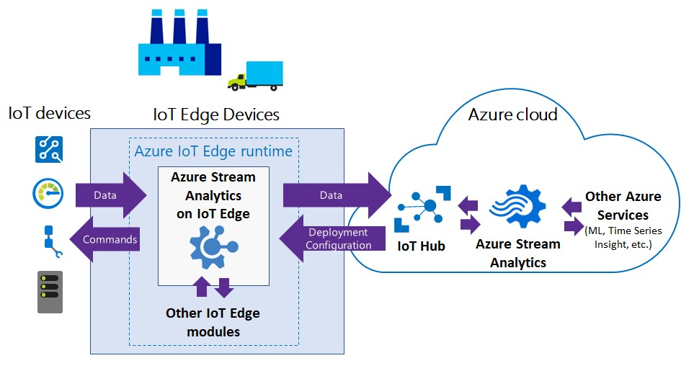

Pros: Lowers Cost, Saving time, preserves privacy and connectivity issues

### 2/ Data Centre with Cloud Platform

The data centre is stores your data in public cloud. The data is for Specific ornization when they need for future plan and goals

Cons: Data Centre is a better option than in-house data centre, Cause the data in-house is expensive. And data center is more cyubersecurity, performance and more reliability.

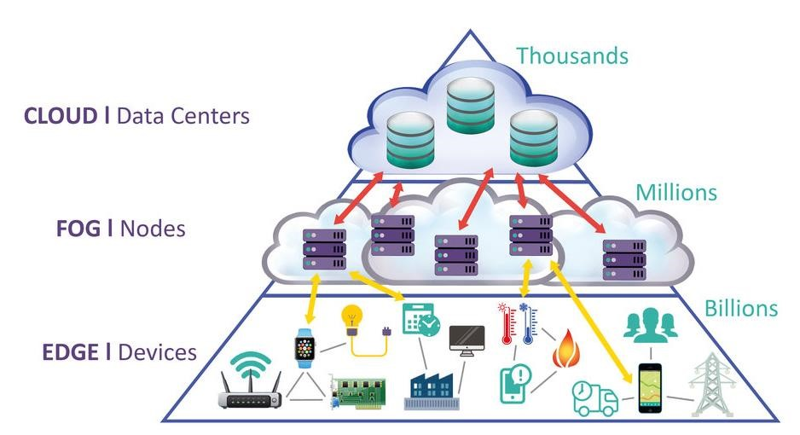

## -=Frameworks (https://github.com/SmingHub/Sming, n.d.)

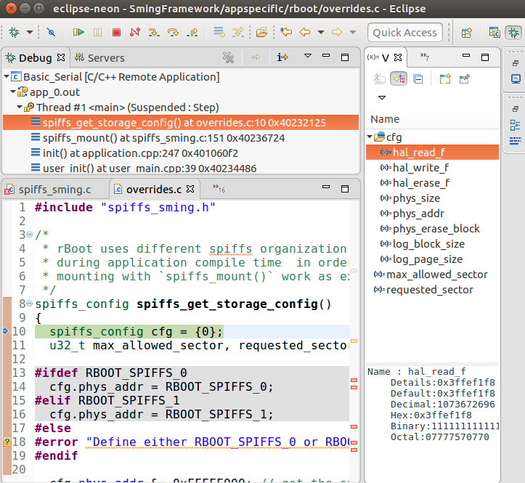

There are several platforms and initiatives for ESP8266 projects. The Sming Framework is one of them that stands tall.

For a variety of factors, Sming is my preferred framework for ESP8266 programming. At least for me the most important ones are:

-Relatively good

The majority of ESP8266 frameworks are still under development and lack lots of functionality. As a result, you'll finally end up with a framework that,just like the Olimex Arduino Type library will facilitate yourstart, but with more complex applications, you'll should do lots more work yourself.

-Simple to build with it,

The framework is written in C++, so for men like myself who haven't coded in C in 15 years but are proficient in translated languages like PHP, the learning curve isn't as steep.  
Has cool attributes

In Sming, updating over the air is feasible with just some lines of code. Try to find this in plain C.

## =- Hardware Andrunio

### NodeMCU ESP8266 WiFi Development Board:

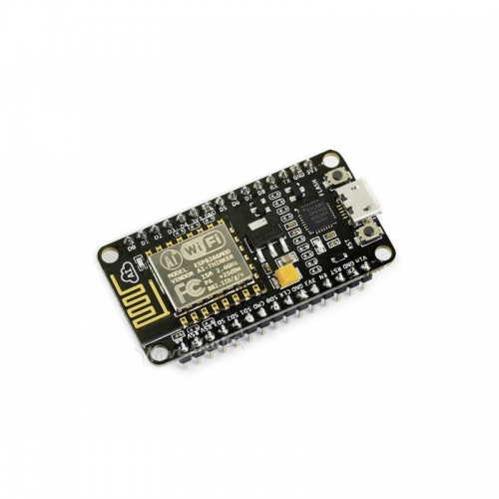

**INTRODUCE**

This is a NodeMCU module with Wifi, on-board CP2102, and keys based on the ESP8266. Many open source resources, this module allows development in a variety of ways, including Lua/AT command/MicroPython/Arduino/IOT, and others, allowing you to swiftly build IoT applications.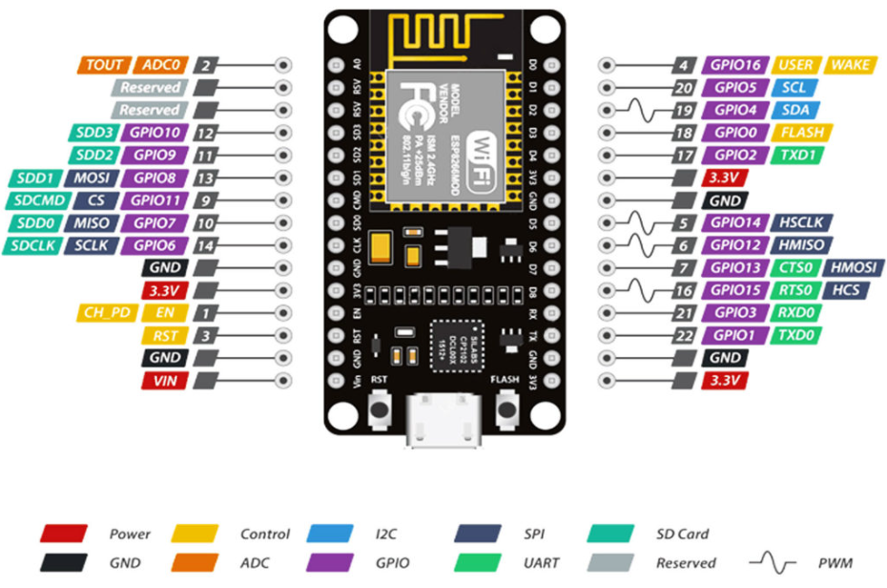

### Anduino IoT Product

Andruino product is a hardware company that designed to make easier for developers to share Hardware. With the form factir, feather accessories

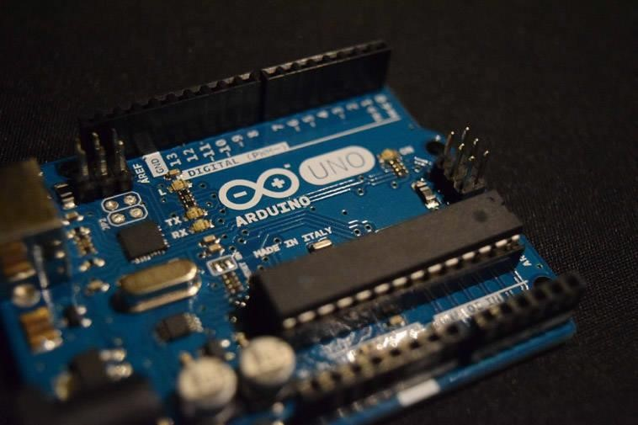

### Adafruit Range of Development boards

## -=Tools

### Blynk IoT platform

Blynk is an Internet-of-Things platform designed to make development and implementation of smart IoT devices quick and easy.

It can be used to read, store, and visualize sensor data and control hardware remotely.

Blynk can control IOT device with BLYNK APP from BLYNK server & Library

(htt10)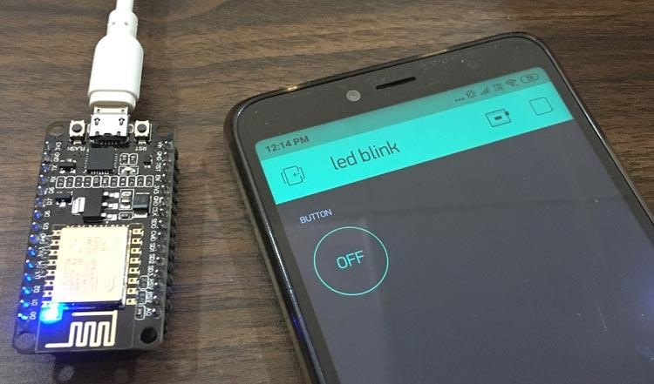

### The Integrated Development Environment (IDE)

in this project was used Arduino IDE:

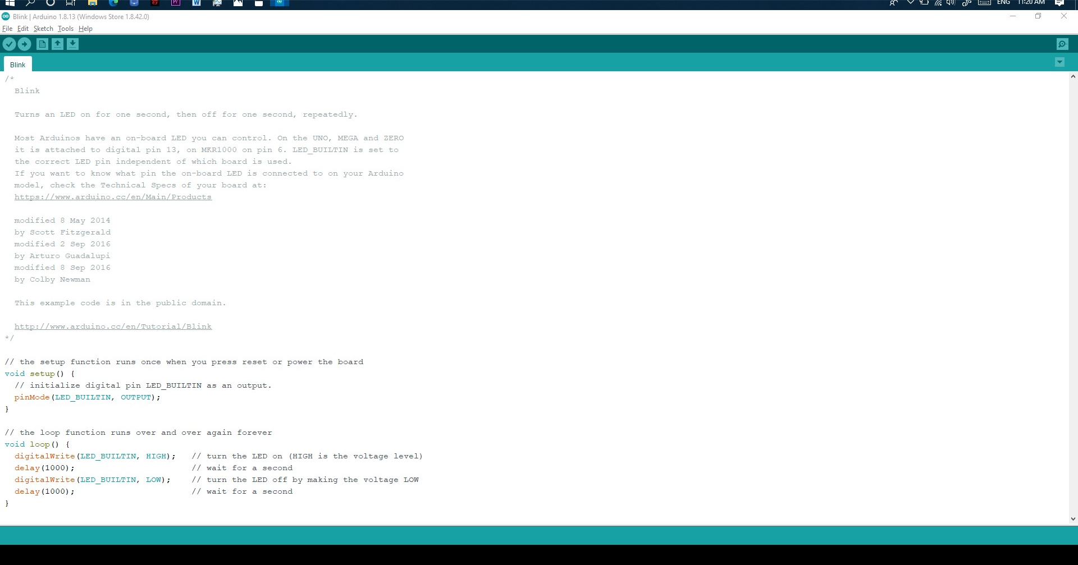

Two IDE device connections and two motherboard connectors for 2 data cables are found on the IDE interface. An IDE-integrated controller transfers 512-byte blocks from the drive to the motherboard, which can impediment to four chipset-controlled IDE devices in one system.

Hard drive and CD-ROM interfaces are found on nearly all personal computers (PCs). The disk connects to the motherboard through the most IDE reference to only 1 cable. One IDE cable connects the CD-ROM drive and other storage devices.

The standard IDE (ATA/ATAPI) connection has two distinct types. The IDE/ATA cable connects the info connection, while the standardized power connector supplies power.

The programming software is straightforward and simple

Arduino has been utilized in thousands of various projects and apps. The Arduino software is straightforward to use yet strong enough for knowledgeable users.

## -=API techniques

### AWS IoT

(https://www.hackster.io/dansku/use-a-raspberry-pi-to-communicate-with-amazon-aws-iot-e37525, n.d.)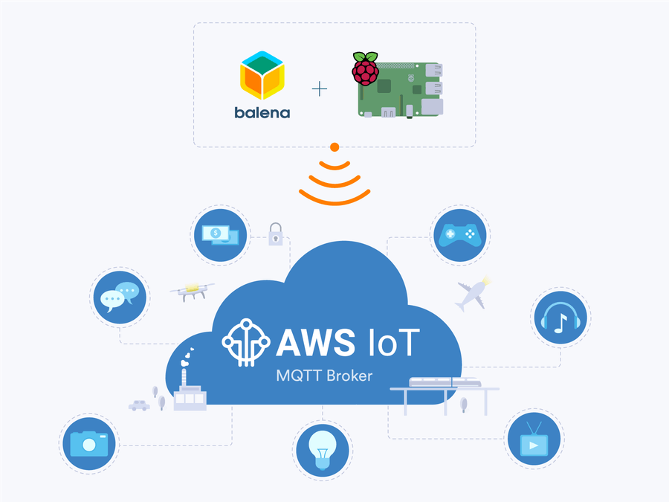

-Industrial, consumer, and commercial IoT solutions:

There are billions of gadgets in houses, industries, oil wells, hospitals, autos, and a variety of other places. With the proliferation of devices, you'll need more solutions to connect them and gather, store, and analyze device data.

-Detailed and rich:

AWS offers a wide range of IoT services, from the edge to the cloud. AWS IoT is the only cloud-based supplier that combines rich data management and analytics in simple services built for high-noise IoT data.

AWS IoT offers services for all levels of security, including preventative security techniques such as encryption and access control to device data, as well as a service for continuous monitoring and control. Check the setup.

-Integrating superior artificial intelligence:

To make things smarter, AWS integrates AI and IoT. You may build the model in the cloud and deliver it to devices where it runs twice as fast as other services.

-Large-scale evidence:

With billions of devices and trillions of communications, AWS IoT is built on a reliable, secure, and scalable cloud architecture. AWS IoT connects with other AWS services, allowing you to create a holistic solution.

# P4 Determine a specific problem to solve using IoT.

## Problem:

* Give out your idea about any IoT application used for solving any problem in real world Make a plant watering system Application by checking soil & air moisture through the Internet By using:

### Discuss about the reason for your selection

1. Making is a activity way to help make money and help the country

Plant is very important for Earth

Soil & air moisture is very important for help plant growing

Application is a smart IOT for control the Soil & air moisture for plant watering

1. Because that helps everyone with Iot application for plant more easy, faster and more effective

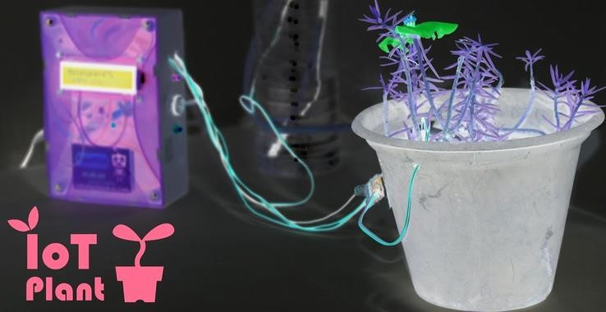

## Solution:

## Sensor dht11 arduino

For read the temperature - humidity from the sensor and output is data

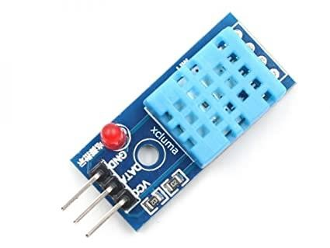 (xcluma, n.d.)

## Sensor Servo SG90

For control the output water with the IOT application

 (htt)

## Draw DEMO my smart IOT for control the Soil & air moisture for plant watering

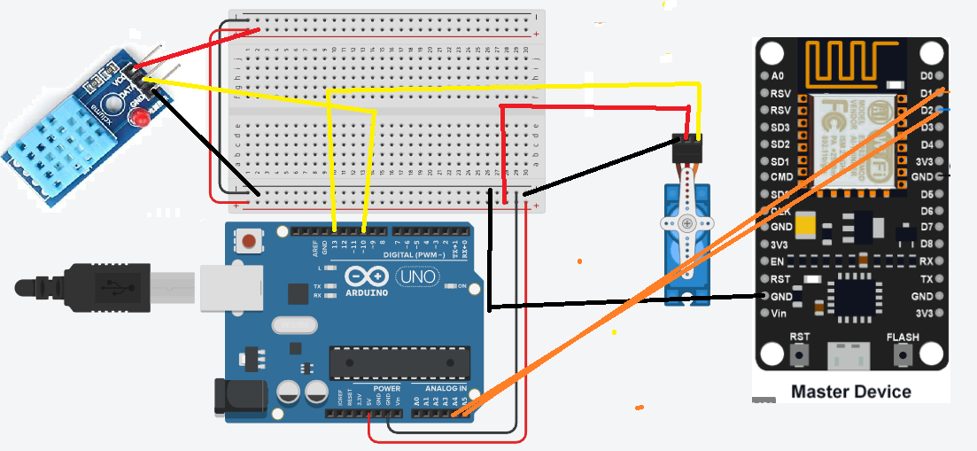

## Table -Connect sensor with Arduino circuit

|  |  |  |  |
| --- | --- | --- | --- |
| Sensor dht11 arduino | Sensor Servo SG90 | ESP8266 | **Arduino UNO R3** |
| GND | GND | GND | GND |
| Vcc | Vcc | Vcc | 5V |
| Signal | Signal | 2 Signal | Servo: D13  Dht11: D10 ESP8266: A4 A5 |

[Powered by TCPDF (www.tcpdf.org)](http://www.tcpdf.org/)